FOR IMMEDIATE RELEASE:
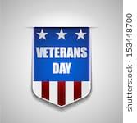 WILLS FOR VETERANS 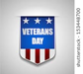
In observation of Veterans Day the Grand Traverse-Leelanau-Antrim Bar Association is offering free Wills and Durable Powers of Attorney for estate planning to Veterans

What: Veterans Day, celebrated every November 11, is a national day set aside to honor all those who served in the United States armed forces. Veterans Day provides an opportunity to give thanks to those who protect our liberty and the freedoms that all Americans enjoy.

Who: Services will be provided pro bono (free of charge) to any veteran by volunteer licensed attorneys from our local area.

When: Veterans Day - November 11, from 12:00 p.m. to 4:00 p.m. (last intake at 4:00 p.m.)

Where: Traverse Area District Library, 610 Woodmere Ave., Traverse City, MI 49686

No registration required but RSVP appreciated

Please RSVP or email any questions to: admin@gtlaba.org.

Please bring valid ID and proof of military service.

This program is not sponsored or endorsed by the Traverse Area District Library.

